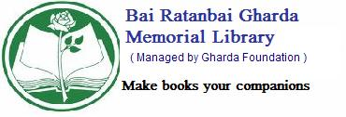

ASK LIBRARIAN

What does “Ask a Librarian”? service do?
It answers simple factual questions.
Please e-mail at librarian@ghardalibrarybandra.org at using following format.

- Name :_____________________
- Address :_____________________
- Library Membership No. :_____________________
- Contact No. :_____________________
- Email ID :_____________________
- Questions/Suggestions :_____________________

You will be contacted by the Librarian/Library Staff. Please describe your questions in detail.
For additional assistance, please visit the Library or call at (022) 26419309

